Table of Content:

- Server Connection
- Activate or Deactivate Users
- Add Users to Projects
- Create Projects
- Create Users
- Delete Users
- Delete Users from Projects
- List Domains and Projects
- List Users Group Permission

- Server Connection – Connect to your ALM instance to perform tasks using SaaS Administration REST API
- Bring up the QC_SaaSAdminAddon.xlsm
- Navigate to the Connection tab
- Enter the ALM Server URL
- Enter your API Key and Secret. If you don’t have this information then, you need to request from you Customer Admin to create one.
- Enter the Customer ID. You can get this information by logging into the Administration Addon -> SaaS Information -> Reports -> Parameters -> Customer ID report.
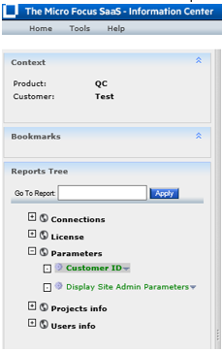

- Select the task you want to perform. Below are the possible Tasks
- Activate/Deactivate Users
- Add Users to Projects
- Create Projects
- Create Users
- Delete Users
- List Domains and Projects
- List Users Group Permission
- Click on “Connect” button to execute
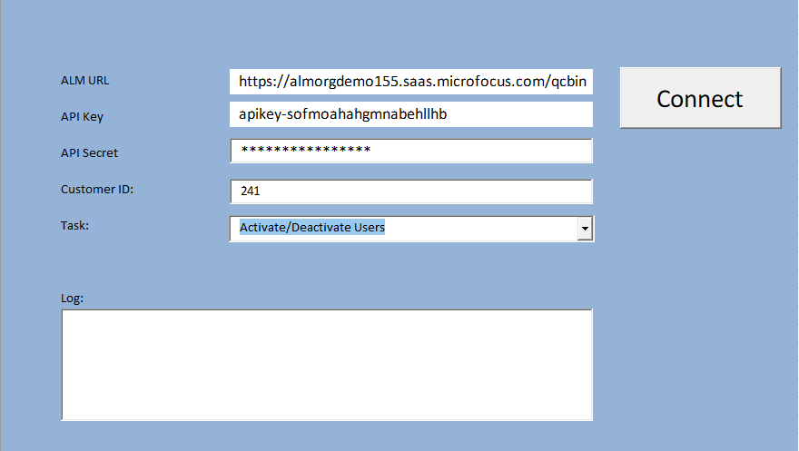
- Activate or Deactivate Users – Use REST API to Activate or Deactivate users.
- Navigate to the “Activate or Deactivate Users” tab
- Fill in the Excel row(s) with the user’s information to active/deactivate
login-name – Name of the user to apply task
is-activate – Set value to “true” to activate user and “false” to deactivate

Example:
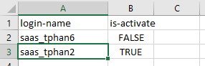

- Add Uses to Projects – Use REST API to a add users to projects and groups. This example can also be used to remove a user from a group in a project. A user will need to belong to at least 1 group. You cannot remove a user from all groups in a project.
- Navigate to the “Add Users to Projects” tab
- Fill in the Excel row(s) with the user’s information to add to project
domain – Name of domain
project - Name of project
user – Name of user to be added
role-name – Name of the group in the project
is-member – Set value to “Y” to add user to group and “N” to remove user from group

Example:
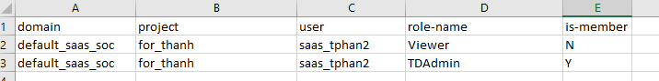

- Create Projects – Use REST API to add project to instance
- Navigate to the “Create Projects” tab
- Fill in the Excel row(s) with project’s information to create
Domain – Name of the domain to place the project in
name - Name of the project to be created
type - Always QCProject
customization - Leave blank. Hard coded value to “[]”
enable-project-vc – Set value to “true” to enable Version Control and “false” to disable Version Control
link-project-to-template – Set value to “true” to link project to template and “false” to unlink from template
link-to-template-copied-project - Set value to “true” to automatically link to source template and “false” to not link to source template
create-from-domain – Name of source domain. Leave blank if not copying project.
deactivate-if-activate - Set value to “true” to deactivate project if project is active before copy and “false” to cancel task if project is still active
create-from-template - Name of source template. Leave blank if not copying template project.
extension-name-to-enable – Leave blank. No documentation on possible values
create-from-project – Name of source project. Leave blank if not copying project.
type-to-copy-from – Leave value as “0”. No documentation on parameter.
is-active – Set value to “true” to activate project upon completion and “false” to deactivate it upon completion
is-enable-pc-extension - – Set value to “true” to enable PC extension upon completion and “false” to not enable “PC” extension

Example:
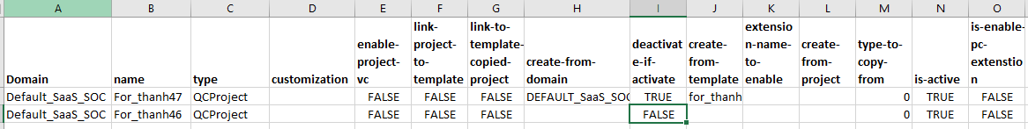

- Create Users – Use REST API to create new users in instance
- Navigate to the “Create Users” tab
- Fill in the Excel row(s) with user’s information to create
email - Email of the user. Must be unique for SSO.
phone - Phone of the user
role – SaaS Add-on Role. Possible value are “Basic User” and “Customer Admin”. Other roles are possible if existing in instance.
login-name – Login Name of the user. Must be unique.
full-name – Full Name of the user.
idp-name – For SSO. Possible value is “alm” for SSO and “local” for non SSO users.
identity-key – For SSO. Must be unique value. Can be email or login name depending on setup. Field is case sensitive.
send-notification - Set value to “true” to send email to user with login info and “false” to not send email
is-active - Set value to “true” to make user active or “false” to deactivate user

Example:

- Delete Users – Use REST API to delete users from instance
- Navigate to the “Delete Users” tab
- Fill in the Excel row(s) with the project’s information to delete
login-name – Name of the user to delete from instance

Example:
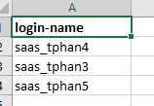

- Delete Users from Projects – Use REST API to delete users from projects
- Navigate to the “Delete Users From Projects” tab
- Fill in the Excel row(s) with the user’s information to delete
domain - Name of domain
project - Name of prjoect
user - Name of the user to delete from project

Example:
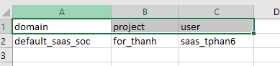

- List Projects and Domain – Use REST API to get list of domains and projects in the instance. Only the list of projects under the End Customer will be displayed.
- Navigate to the “List Domains and Projects” tab
Example:
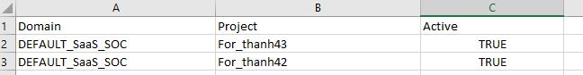

- List Users Group Permission – Use REST API to get list of users and their group permission for each project under the End Customer. This example will require you the have access to each project because it uses the Core REST API to get the list of users under the project
- Navigate to the “List Users Group Permission” tab
Example:

